TOWN OF HANCOCK
P.O. BOX #100
HANCOCK, VERMONT 05748
TELEPHONE (802)-767 - 3660

PROSPECTUS FOR CHURCHVILL RD.
PAVEMENT REMOVAL/ROAD BED REPAIR/DITCH WORK
4/22/2022

The Town of Hancock is seeking construction bids for road work on Churchville Road.

Insurance Requirements: The Town of Hancock requires that all Contractors or Persons working for the Town of Hancock carry a General liability Policy of no less than One million Dollars ($1,000,000.00) with the Town of Hancock being an additional Insured. Any Contractor or Persons working for the Town of Hancock having Employees must provide the Town of Hancock with a Certificate of Worker’s Compensation meeting all State of Vermont and Federal Statues. All Insurance Certificates must be on file with the Hancock Town Clerk before work is to begin.

Additional Requirements: The Town of Hancock requires that any Vehicle exceeding the twenty four thousand pound weight limit (24,000) with or without load, obtain an overweight permit. The Town of Hancock has restrictions on its roads and obtaining this permit is the only way to operate legally on the Hancock Road System.

Additional Requirement: The Town of Hancock requires that all construction sites be properly warned with the correct signage and cones.

Additional Requirement: The Town of Hancock requires that the Contractor provide Traffic control as needed.

Contractor Responsibilities: Furnish all Equipment, Materials, Insurances, Labor and Knowledge necessary to complete the project described herein within the timeframe allowed.

Town of Hancock’s Responsibilities: Direction so the herein described project can be completed in the timeframe allowed.

PROJECT DESCRIPTION

Location:
The worksite is located approximately 1000 feet up Churchville Rd from the entrance of the road off of Route 100 in Hancock. Each end of the worksite is currently marked by orange painted markings. The paved area to be removed is 124’ x 16’ (Approximately 1,984 square feet)

Project Objectives:
Prepare road for paving in 2023.
Raise height of road to eliminate the depression in the road.
Have finished road bed sloped at 1-2 % to facilitate water run-off into ditch.

Materials:

- 3/4” crushed gravel.
- 1-2” ditch stone.
- 4-6” ditch stone.
- Road stabilization fabric.
- Filter fabric for ditch work.

Description of Work:

Pavement removal
Contractor shall cut out and remove all existing pavement between orange paint markings. This is approximately 124 linear feet of Churchville Rd. Removed pavement shall be carted away and disposed of in full compliance with all State or Federal regulations.

Prepare Road Bed
Contractor shall dig down and remove 8” of the road bed. This material shall be removed and disposed of by the Contractor.
Contractor shall then place road stabilization fabric throughout the entire excavated area.
Contractor shall replace removed road bed material with 3/4 inch crushed gravel. This gravel shall be added in quantities that remove the current depression in the road. The final road bed shall have no depression and be level with Churchville Rd.
The ¾ crushed gravel shall be compacted in two lifts so as to withstand the road traffic for the year waiting period before paving.
The final road bed shall be sloped at a grade of 1% to 2% towards the south side of Churchville Rd so that water runs into the ditch that runs along the south side of the project area.
The goal is to have this road paved in 2023 and that the final paved road be sloped to allow water to run into the ditch on the south side of Churchville Rd.

In the event that the road bed condition is found to be in need of further remediation after the removal of 8” of material, further road bed material may need to be removed and replaced with new 3/4 crushed gravel. In this event, the Contractor shall be compensated for time and materials in an amount that is acceptable to the Contractor and the Town of Hancock.

Ditch Work:
Contractor will clean and shape the ditch that runs along the south side of Churchville Rd. from the west side of the project area to a point 20 feet beyond the end of the paved portion of Churchville Rd.
The first section of the ditch, running from the west side of the project to the under the road culvert, shall be cleaned and shaped, lined with filter fabric, and then filled with 1-2 inch stone to a level 2” below the finished height Churchville Rd. Ditch work in this section shall avoid damage to the roots of the large tree on the south side of the project area.
The ditch that continues east from the under the road culvert shall be cleaned and shaped and lined with filter fabric to a point 20 feet beyond the end of the existing pavement and then lined with 4-6” stone.

End of Description of Work.

Resolution of Disputes: The Town of Hancock and the winning Contractor agree to hire an independent Arbitrator to settle any and all disputes that may arise. Both parties will share the expense of an Arbitrator equally.

Warranty of work performed: Contractor will guarantee work performed to the full satisfaction of the Hancock Road Commissioner and the Hancock Select Board for a period of not less than one full year (12months) from the date of the final inspection. This guarantee shall cover all workmanship and any materials the Contractor supplied. In the event of a failure in any of the workmanship or materials, the Contractor will, at their expense, replace or redo any part that has failed and any other damages that may have occurred because of that failure.

This project will be overseen by the Hancock Road Commissioner all inquiries are to be directed to the Road Commissioner (Dan Perera 802-767-4851 / dan@enigmamuseum.com). If, for some reason, the Road Commissioner is unavailable, you may direct your question to the Hancock Select Board Chair (Scott Gillette 802-770-0727).

Project completion date: October 30th, 2022

Bids due: _Tuesday, June 7_ at 2:00 PM at the Hancock Town Clerks office.

Bids can be hand delivered to the Hancock Town Clerk’s office for drop off in the outside drop box or Bids can be mailed so long as they are received any time before 2pm on Tuesday June 7, 2022. All Bids must be in a sealed envelope marked, Churchville Rd Road Work / Town of Hancock.

Bids submitted via mail should be sent to Town of Hancock, Churchville Rd Road Work, PO Box 100, Hancock, VT 05748.

No bids will be accepted by the use of e-mail.

THE TOWN OF HANCOCK RESERVES THE RIGHT TO REJECT ANY AND ALL BIDS. By order of the Hancock Select Board

BID AND SIGNATURE SHEET FOR HANCOCK ROAD PROJECTS

__________________________________ SUBMITTS THE FOLLOWING BID BASED ON THE
PROSPECTUS PROVIDED BY THE TOWN OF HANCOCK. IT IS FUTHER UNDERSTOOD THAT BY SUBMITTING THIS BID I/WE AGREE TO ALL THE TERMS DESCRIBED HEREIN. IT IS FURTHERMORE UNDERSTOOD THAT CONSTRUCTION PROJECTS HAVE MANY VARIABLES AND EXTRAS AND CHANGES MAY BE MADE AS THE PROJECT PROCEEDS. WE AGREE TO WORK WITH THE TOWN OF HANCOCK ON ALL CHANGES. WE FURTHER AGREE THAT ALL CHANGES WILL BE AGREED TO IN WRITING BEFORE ANY WORK IS TO PROCEED.

BID SUBMITTED:___________________________ DATE:________________________
For CHURCHVILL RD. 2022
PAVEMENT REMOVAL/ROAD BED REPAIR/DITCH WORK

SIGNATURES OF COMPANYS AUTHORIZED AGENTS: _________________________________

_________________________________

_________________________________

THE TOWN OF HANCOCK HEREBY ACCEPTS THE BID SUBMITTED BY:

__________________________________ ON _________________ THE HANCOCK SELECT
BOARD AGREES TO THE TERMS STATED WITHIN THIS PROSPECTUS AND FURTHER AGREES

THAT THE ABOVE NAMED COMPANY MAY BEGIN WORK AS STATED WITHIN.

HANCOCK SELECT BOARD: _____________________________________

_____________________________________

_____________________________________

DATED:______________
Project site looking east.

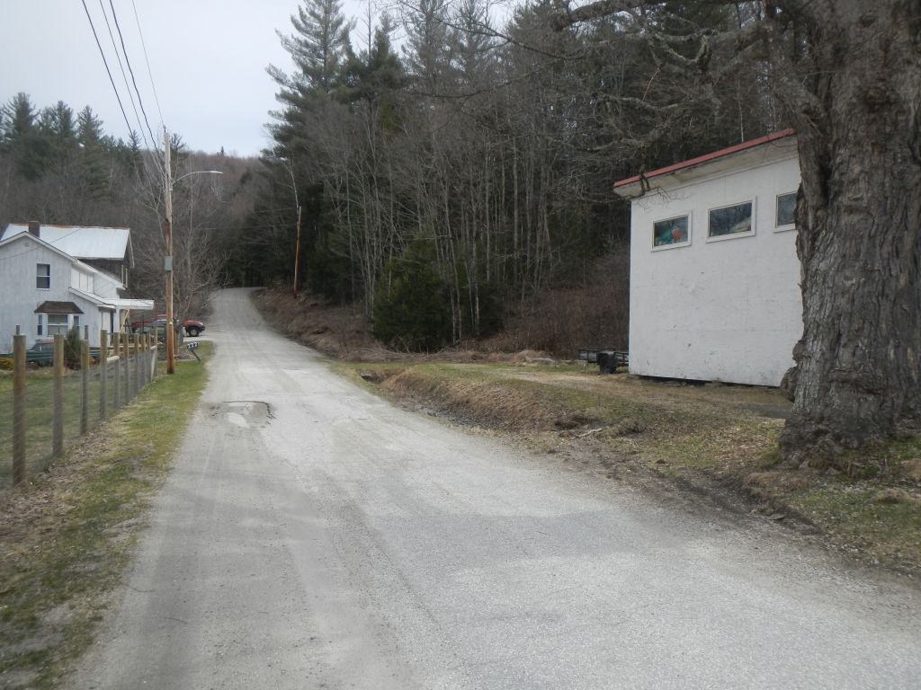

Project site looking west.

