TOWN OF HANCOCK
P.O. BOX #100
HANCOCK, VERMONT 05748
TELEPHONE (802)-767 - 3660

PROSPECTUS FOR FASSETT HILL RD.
DITCH CLEANING/SHAPING AND STONE LINING
4/11/2022

The Town of Hancock is seeking construction bids for ditch cleaning and shaping and lining on Fassett Hill Road.

Insurance Requirements: The Town of Hancock requires that all Contractors or Persons working for the Town of Hancock carry a General liability Policy of no less than One million Dollars ($1,000,000.00) with the Town of Hancock being an additional Insured. Any Contractor or Persons working for the Town of Hancock having Employees must provide the Town of Hancock with a Certificate of Worker’s Compensation meeting all State of Vermont and Federal Statues. All Insurance Certificates must be on file with the Hancock Town Clerk before work is to begin.

Additional Requirements: The Town of Hancock requires that any Vehicle exceeding the twenty four thousand pound weight limit (24,000) with or without load, obtain an overweight permit. The Town of Hancock has restrictions on its roads and obtaining this permit is the only way to operate legally on the Hancock Road System.

Additional Requirement: The Town of Hancock requires that all construction sites be properly warned with the correct signage and cones.

Additional Requirement: The Town of Hancock requires that the Contractor provide Traffic control as needed.

Contractor Responsibilities: Furnish all Equipment, Materials, Insurances, Labor and Knowledge necessary to complete the project described herein within the timeframe allowed.

Town of Hancock’s Responsibilities: Direction so the herein described project can be completed in the timeframe allowed.

Location: The worksite is located 296 yards up Fassett Hill Rd from the entrance of the road off of Route 125 in Hancock. The area to receive ditch work is on the right side and runs from the sixth under-road culvert to the tenth under-road culvert. The total distance is approximately 800 feet. Each end of the worksite is currently marked by stakes with red marking tape.

Materials:

- 7” Erosion Stone (Quantities to be determined by contractor based on drawing provided by the Town of Hancock)

- 1 ½” Clean Stone NO FINES (Quantities to be determined by Contractor based on drawings provided by the Town of Hancock)

- Filter Fabric to line all ditch work.

- The Town of Hancock requires that all bare ground including any areas provided for the waste materials from the ditch cleaning be hydroseeded or seeded and mulched with a Contractor’s Mix. All bare ground must be covered post construction.

Description of Work:
Ditch Work:

- Contractor will clean and shape the ditch area. At a minimum, the Town of Hancock requires the base width to be 2’. The depth of the ditch should be 4’ at the center line with the base of the Fassett Hill Road as a completion height. Exceptions to these requirements will be considered by the Road Commissioner in the event that ledge is encountered. All stone must be 6” below the edge of Fassett Hill Road.
See Diagram on last page.
It will be the Contractor’s responsibility to remove all excess materials generated from this project.

- Once the ditch has been cleaned and shaped the Contractor will place filter fabric and then the 1 ½” clean stone in the ditch, keeping the clean stone 6” below the side of the road. The bank side will have the same clean stone height requirement.

- The seven inch ditch stone to a minimum depth of 4’ across the base width then stoning the side slopes of the ditch to the required height.

- Any existing bank retaining stones to be reset as needed. Any exposed bank soils not covered with retaining stones must be covered as stated above.

Culvert Work - see attached map for culvert numbering:
Culvert #8 - clean and stone line culvert inlet.

Culvert #9 - clean and stone line culvert inlet.

Culvert #10 – culvert removed / no culvert.

Culvert #11 – clean and stone line culvert inlet.

Culvert #12 – clean and stone line culvert inlet.

Other:
There is a small parcel of land at the bottom of Fassett Hill Rd. between the road and the river that can be used for staging of vehicles and/or materials. This land must be restored to prior condition after construction is complete.

Resolution of Disputes: The Town of Hancock and the winning Contractor agree to hire an independent Arbitrator to settle any and all disputes that may arise. Both parties will share the expense of an Arbitrator equally.

Warranty of work performed: Contractor will guarantee work performed to the full satisfaction of the Hancock Road Commissioner and the Hancock Select Board for a period of not less than one full year (12months) from the date of the final inspection. This guarantee shall cover all workmanship and any materials the Contractor supplied. In the event of a failure in any of the workmanship or materials, the Contractor will, at their expense, replace or redo any part that has failed and any other damages that may have occurred because of that failure.

This project will be overseen by the Hancock Road Commissioner all inquiries are to be directed to the Road Commissioner (Dan Perera 802-767-4851). If, for some reason, the Road Commissioner is unavailable, you may direct your question to the Hancock Select Board Chair (Monica Collins 802-767-3570).

Project completion date: September 30th, 2022

Bids due: _Tuesday, June 7_ at 2:00 PM at the Hancock Town Clerks office.

Bids can be hand delivered to the Hancock Town Clerk’s office for drop off in the outside drop box or Bids can be mailed so long as they are received any time before 2pm on Tuesday June 7, 2022. All Bids must be in a sealed envelope marked, Fassett Hill Rd Ditching / Town of Hancock.

Bids submitted via mail should be sent to Town of Hancock, Fassett Hill Rd Ditching, PO Box 100, Hancock, VT 05748.

No bids will be accepted by the use of e-mail.

THE TOWN OF HANCOCK RESERVES THE RIGHT TO REJECT ANY AND ALL BIDS. By order of the Hancock Select Board

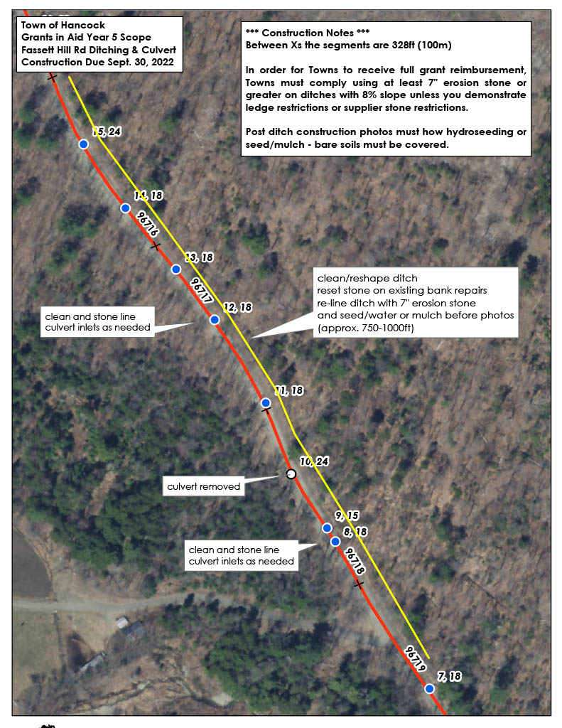
BID AND SIGNATURE SHEET FOR HANCOCK ROAD PROJECTS

__________________________________ SUBMITTS THE FOLLOWING BID BASED ON THE
PROSPECTUS PROVIDED BY THE TOWN OF HANCOCK. IT IS FUTHER UNDERSTOOD THAT BY SUBMITTING THIS BID I/WE AGREE TO ALL THE TERMS DESCRIBED HEREIN. IT IS FURTHERMORE UNDERSTOOD THAT CONSTRUCTION PROJECTS HAVE MANY VARIABLES AND EXTRAS AND CHANGES MAY BE MADE AS THE PROJECT PROCEEDS. WE AGREE TO WORK WITH THE TOWN OF HANCOCK ON ALL CHANGES. WE FURTHER AGREE THAT ALL CHANGES WILL BE AGREED TO IN WRITING BEFORE ANY WORK IS TO PROCEED.

BID SUBMITTED:___________________________ DATE:________________________
For 2022 Fassett Hill Rd Ditch Cleaning/Shaping Project.

SIGNATURES OF COMPANYS AUTHORIZED AGENTS: _________________________________

_________________________________

_________________________________

THE TOWN OF HANCOCK HEREBY ACCEPTS THE BID SUBMITTED BY:

__________________________________ ON _________________ THE HANCOCK SELECT
BOARD AGREES TO THE TERMS STATED WITHIN THIS PROSPECTUS AND FURTHER AGREES

THAT THE ABOVE NAMED COMPANY MAY BEGIN WORK AS STATED WITHIN.

HANCOCK SELECT BOARD: _____________________________________

_____________________________________

_____________________________________

DATED:______________
