TOWN OF HANCOCK
P.O. BOX #100
HANCOCK, VERMONT 05748
TELEPHONE (802)-767 - 3660

PROSPECTUS FOR THE INSTALLATION OF 90 LINEAR FEET OF TYPE III RIPRAP AND GUARDRAIL FOR THE PROTECTION OF KILLOOLEET ROAD
7/6/2022

The Town of Hancock is seeking construction bids for the installation of type III Riprap along a 90 foot length of Killooleet Road in Hancock, Vermont.

Insurance Requirements: The Town of Hancock requires that all Contractors or Persons working for the Town of Hancock carry a General liability Policy of no less than One million Dollars ($1,000,000.00) with the Town of Hancock being an additional Insured. Any Contractor or Persons working for the Town of Hancock having Employees must provide the Town of Hancock with a Certificate of Worker’s Compensation meeting all State of Vermont and Federal Statues. All Insurance Certificates must be on file with the Hancock Town Clerk before work is to begin.

Additional Requirements: The Town of Hancock requires that any Vehicle exceeding the twenty-four thousand pound weight limit (24,000) with or without load, obtain an overweight permit. The Town of Hancock has restrictions on its roads and obtaining this permit is the only way to operate legally on the Hancock Road System.

Additional Requirement: The Town of Hancock requires that all construction sites be properly warned with the correct signage and cones.

Additional Requirement: The Town of Hancock requires that the Contractor provide Traffic control as needed.

Contractor Responsibilities: Furnish all Equipment, Materials, Insurances, Labor and Knowledge necessary to complete the project described herein within the timeframe allowed.

Town of Hancock’s Responsibilities: Direction so the herein described project can be completed in the timeframe allowed.

Location: The worksite is located 195 feet up Killooleet Rd from the entrance of the road off of Route 100 in Hancock. The area requiring construction work is on the right side of the road (river side) and runs for 90 linear feet. Each end of the worksite is currently marked by stakes with orange marking tape.

Materials:

1) See attached diagram labeled “Stone Fill Slope Protection With Stone Toe Wall” for materials required.
2) The Town of Hancock requires that all bare ground including any areas provided for the waste materials from the construction be hydroseeded or seeded and mulched with a Contractor’s Mix. All bare ground must be covered post construction.

Description of Work:

- Contractor will install 90 linear feet of Type III Riprap for the protection of Killooleet Road from erosion and high-water events. See Diagram on last page - “Stone Fill Slope Protection with Stone Toe Wall”.

- A pre-construction meeting is required with the contractor, a representative from the Town of Hancock, and the ANR River Management Engineer.

- The submission of a water control plan shall be provided no less than 2 weeks prior to the start of construction and approved by the Regional River Management Engineer.

- It will be the Contractor’s responsibility to remove all excess materials generated from this project.

- This project shall meet the standards detailed in subsection E.2.1 and E.2.2 of the ANR Stream Alteration General Permit.

- This project will meet the Stream Alteration Standards to the greatest extent possible.

- Work shall not begin before August 23, 2022.

- Work shall be completed by October 31, 2022.

- A Vermont Stream Alteration Permit has been issued for this project and a copy is attached to this prospectus.

- The ANR River Management Engineer for this project is Jaron Borg – 802-371-8342 / jaron.borg@vermont.gov

- No rocks shall be placed on the paved portion of Killooleet Rd. All measures shall be taken to protect the paved portion of the road.

Resolution of Disputes: The Town of Hancock and the winning Contractor agree to hire an independent Arbitrator to settle any and all disputes that may arise. Both parties will share the expense of an Arbitrator equally.

Warranty of work performed: Contractor will guarantee work performed to the full satisfaction of the Hancock Road Commissioner and the Hancock Select Board for a period of not less than one full year (12months) from the date of the final inspection. This guarantee shall cover all workmanship and any materials the Contractor supplied. In the event of a failure in any of the workmanship or materials, the Contractor will, at their expense, replace or redo any part that has failed and any other damages that may have occurred because of that failure.

This project will be overseen by the Hancock Road Commissioner all inquiries are to be directed to the Road Commissioner (Dan Perera 802-767-4851) or dan@enigmamuseum.com. If, for some reason, the Road Commissioner is unavailable, you may direct your question to the Hancock Select Board Chair (Scott Gillette 802-770-0727).

Project completion date: October 31, 2022

Bids due: _Tuesday, August 16, 2022_ at 3:00 PM at the Hancock Town Clerks office.

Bids can be hand delivered to the Hancock Town Clerk’s office for drop off in the outside drop box or Bids can be mailed so long as they are received any time before 3pm on Tuesday August 16, 2022. All Bids must be in a sealed envelope marked, Killooleet Rd Riprap / Town of Hancock.

Bids submitted via mail should be sent to Town of Hancock, Killooleet Rd Riprap, PO Box 100, Hancock, VT 05748.

No bids will be accepted by the use of e-mail.

THE TOWN OF HANCOCK RESERVES THE RIGHT TO REJECT ANY AND ALL BIDS. By order of the Hancock Select Board
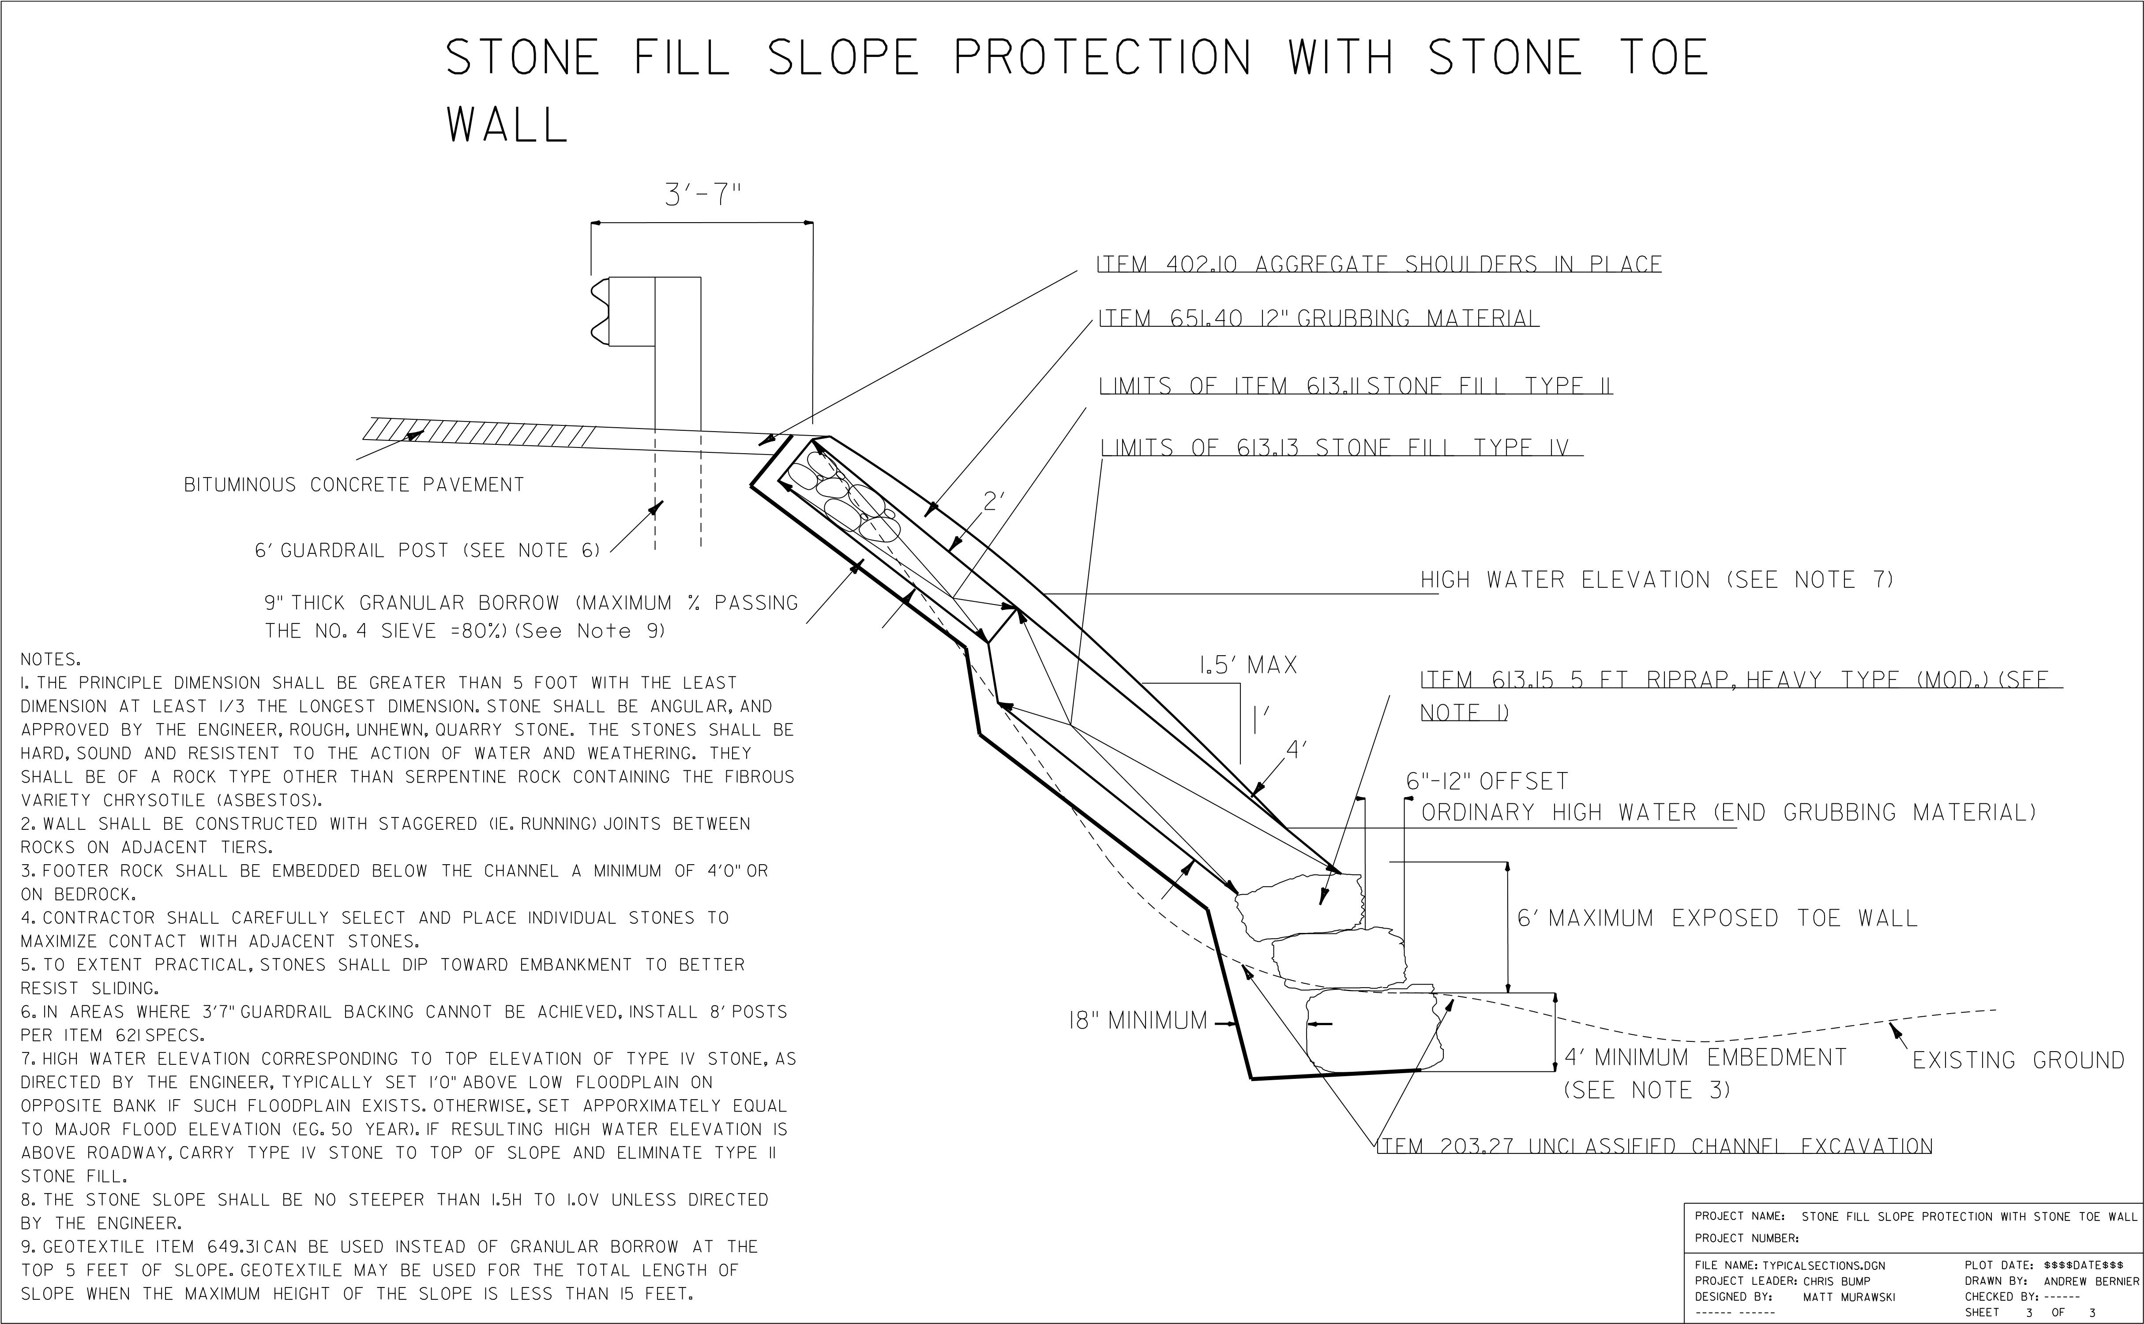
AUTHORIZATION TO CONDUCT
NEXT FLOOD MEASURES
Pursuant to Section F of the Vermont Stream Alteration General Permit

See next page for permit details.
A. Permitted Project Information:
Project Number: NFM-3016 Name: Town of Hancock Phone: (802) 767-3660
Mailing Address: PO Box 100, Hancock, VT 05748 Email: dan@enigmamuseum.com
Project Location: Killooleet Road, Hancock (43.9258, -72.8422)
B. Findings:
The Secretary of the Vermont Agency of Natural Resources (VT ANR) has determined that:
- This project consists of installation of 90 linear feet of type III Riprap for protection of Killooleet Road.
- The proposed activity is eligible for coverage under the VT ANR Stream Alteration General Permit.
- The proposed activity will meet the terms and conditions of the General Permit provided:
a) The project will be completed in accordance with the plans provided on 06/13/2022.
C. Standard Conditions:
- The project is proportional to the threat and conditioned to cease when the threat to life or to improved property has ended.
- The project will not result in a threat to life, public health or safety.
- The project will meet the standards detailed in subsection E.2.1 and E.2.2 of the General Permit.
- The project will meet Stream Alteration Standards to the greatest extent possible.
- A pre-construction meeting is held between the contractor, owner/applicant, and the ANR River Management Engineer.
- The River Management Engineer is notified by phone or email when construction begins and when the project is complete. Contact information is provided on the bottom of this authorization.
- A final construction inspection is required for any culvert and bridge related work.
- Additional conditions: This Permit Expires on 01/01/2023.
- Additional Conditions: submission of a water control plan shall be provided no less than 2 weeks prior to the start of construction and approved by the Regional River Management Engineer

If there are any changes in the project plan or deviation in construction from the plan, the Permittee must notify the River Management Engineer immediately.

If the project is constructed as you have described, as shown on the above referenced approved plans and according to the above conditions, there is no reason to expect any violation of Vermont Water Quality Standards.
D. Authorization:  Signed this 16th day of June, 2022  Julia S. Moore, Secretary, Vermont Agency of Natural Resources  by:  Jaron Borg, River Management Engineer | E. Engineer Contact Information  Engineer Contact: Jaron Borg  Engineer Contact Phone: (802) 371-8342  Engineer Email Address: Jaron.Borg@vermont.gov
Revised August 2016 Next Flood Authorization Page 1 of 1

BID AND SIGNATURE SHEET FOR HANCOCK ROAD PROJECTS

__________________________________ SUBMITTS THE FOLLOWING BID BASED ON THE
PROSPECTUS PROVIDED BY THE TOWN OF HANCOCK. IT IS FUTHER UNDERSTOOD THAT BY SUBMITTING THIS BID I/WE AGREE TO ALL THE TERMS DESCRIBED HEREIN. IT IS FURTHERMORE UNDERSTOOD THAT CONSTRUCTION PROJECTS HAVE MANY VARIABLES AND EXTRAS AND CHANGES MAY BE MADE AS THE PROJECT PROCEEDS. WE AGREE TO WORK WITH THE TOWN OF HANCOCK ON ALL CHANGES. WE FURTHER AGREE THAT ALL CHANGES WILL BE AGREED TO IN WRITING BEFORE ANY WORK IS TO PROCEED.

BID SUBMITTED:___________________________ DATE:________________________
For 2022 Killooleet Rd Riprap installation.

NAME OF BIDDING COMPANY OR INDIVIDUAL: _________________________________

CONTACT INFORMATION: ______________________________________________________

SIGNATURE OF COMPANYS AUTHORIZED AGENT: _________________________________

THE TOWN OF HANCOCK HEREBY ACCEPTS THE BID SUBMITTED BY:

__________________________________ ON _________________ THE HANCOCK SELECT
BOARD AGREES TO THE TERMS STATED WITHIN THIS PROSPECTUS AND FURTHER AGREES

THAT THE ABOVE NAMED COMPANY MAY BEGIN WORK AS STATED WITHIN.

HANCOCK SELECT BOARD: _____________________________________

_____________________________________

_____________________________________

DATED:______________

