Town of Hancock, Vermont
Request for Proposals

Paving

Seeking 5,869 square yards of road paving.

September 20, 2022

Bids/Proposals Due By 3pm Tuesday December 6, 2022

Mail Bids to:
Town of Hancock – Select Board
PO Box 100
Hancock, VT 05748

Contact Information:
Dan Perera
Select Board Member
dan@enigmamuseum.com
802-767-4851

Introduction

The Town of Hancock, Vermont, (“Town”) is accepting proposals from paving companies (“Proposers”) for paving. The total square feet of paving is 52821 (5,869 square yards).

Proposers are to include detailed specifications including any options, warranties, and timeframe for completion of work.

The Town is exempt from the Vermont State Sales Tax.

All pricing shall be good though the 2023 season.

Proposal Schedule Activity Date
Select Board approval of RFP & Publication 09/20/2022
Mandatory Site Visit 10/24/2022 @ 9am Churchville Rd.
RFP Questions Due 10/28/2022
Bids Due 12/6/2022 by 3pm
Selectboard Bid Opening 12/6/2022
Anticipated Selectboard Decision 12/10/2022

Instructions to Bidders

Mandatory pre-bid meeting.
Contractors wishing to bid on this project must attend a mandatory pre-bid to be held
on 10/24/2022 at 9:00 AM. The location of the pre-bid meeting will be at the
intersection of Churchville Road and Vermont Route 100 in Hancock, VT.

Delivery of Bids
All bids must be submitted in sealed envelopes, addressed to the Town in care of the Selectboard, and plainly marked with the name of the bid.

Bid proposals will be dated stamped on the outside of the envelope immediately upon receipt. Any bid may be withdrawn in writing prior to the schedule time for the opening of bids. Any bids received after the time and date specified shall not be considered and shall be returned.

Bidders shall bid to specifications and any exceptions must be noted. A bidder submitting a bid thereby certifies that the bid is made in good faith without fraud, collusion, or any kind with any other bidder for the same work, and that the bidder is
competing solely on his/her/its behalf without connection with or obligation to any undisclosed person or firm.

Sealed proposals, clearly marked “2022 Paving Proposal” on the outside, must be received no later than 3pm, December 6, 2022 at the following address: Town of Hancock, attn.: Hancock Selectboard, PO Box 100, Hancock, Vermont 05748.

If a bid is delivered by hand, it must be delivered by 3pm on December 6, 2022 to the Town Clerks Office, 1027 Route 100, Hancock, Vermont, 05748. There is a lock box outside the office door if needed.

Evaluation of Bids
The Selectboard will consider the following criteria:
• Price
• Bidder's ability to perform within the specified time limits;
• Bidder's experience and reputation, including past performance for the Town;
• Quality of the materials and services specified in the bid;
• Bidder's ability to meet other terms and conditions, including insurance and bond
requirements;
• Nature and size of bidder; and
• The degree to which the proposals respond to all requirements of the requested
specifications.

The Selectboard reserves the right at its sole discretion to reject any and all bids, wholly
or in part, to waive any informalities or any irregularities therein, to accept any bid even though it may not be the lowest bid, to call for rebids, to negotiate with any bidder, and to make an award which in its sole and absolute judgment will best serve the Town's interest.

RFP questions
Any questions regarding the RFP shall be directed via email or phone to Dan Perera.
dan@enigmamuseum.com / 802-767-4851

Delivery
Paving shall be completed on or before September 30, 2023.

Project Locations & Descriptions

- Churchville Rd – Resurface existing paved road
Resurface paved road from the east side of the bridge (located at the junction of Churchville Rd and Route 100) to the end of the pavement where the road continues as a dirt road. Total distance is 1,070 feet.

Minimum of 1.5 inches (nominal) of new pavement except as stated below.

Dimensions:
22’ wide x 285’
16’ wide x 785’
Total 18,830 square feet.

Approximately 1000 feet up Churchville Rd from the entrance of the road off of Route 100 in Hancock is a section of the road that has had the pavement removed and the road bed stabilized. This gravel section of the road is 124’ x 16’ (Approximately 1,984 square feet).

This graveled section of Churchville Rd shall receive 4 inches (nominal) of new pavement with the pavement tapering from 1.5 inches to 4 inches before the start of the graveled section and tapering from 4 inches to 1.5 inches after the end of the graveled section of road.

Contractor shall prepare the existing surface for paving by removing any foreign debris or deleterious material from the road surface either by mechanical broom or hand equipment.

Paving shall butt up against the existing asphalt plug joint on the east end of the bridge at the west end of the project.

Prior to placing asphalt overlay, emulsion shall be applied evenly at a rate of 0.06-.08 Gallons/SY. Emulsion is not a separate bid item and shall be included in price per lump sum project bid.

Compacted average leveling depth shall be one (1.5) inch in a single lift. The specified mix is Type IV- 50 Blow Marshall or Type IVS 50 gyration superpave with PG58-28 binder.

The contractor shall use a current mix design approved by Vermont Agency of Transportation.

All butt joints shall have a minimum 4 foot cold plan taper (1”- zero). Cold planing is not a separate bid item, cold planing shall be included with the lump sum project bid. All cold planed surfaces shall be paved the same day or temporary fillets shall be installed and then removed prior to paving. All costs associated with the installation and removal of fillets shall be incidental to the lump sum project bid.
- Killooleet Rd - Resurface paved road from Route 100 to end of pavement.
Total distance is 1,180 feet.

Minimum of 1.5 inches (nominal) of new pavement.

Dimensions:
13.6’ wide x 1180’
Total 16,048 square feet.

Contractor shall prepare the existing surface for paving by removing any foreign debris or deleterious material from the road surface either by mechanical broom or hand equipment.

Prior to placing asphalt overlay, emulsion shall be applied evenly at a rate of 0.06-.08 Gallons/SY. Emulsion is not a separate bid item and shall be included in price per lump sum project bid.

Compacted average leveling depth shall be one (1.5) inch in a single lift. The specified mix is Type IV- 50 Blow Marshall or Type IVS 50 gyration superpave with PG58-28 binder.

The contractor shall use a current mix design approved by Vermont Agency of Transportation.

All butt joints shall have a minimum 4 foot cold plan taper (1”- zero). Cold planing is not a separate bid item, cold planing shall be included with the lump sum project bid. All cold planed surfaces shall be paved the same day or temporary fillets shall be installed and then removed prior to paving. All costs associated with the installation and removal of fillets shall be incidental to the lump sum project bid.

- Recreation Drive - Resurface paved road from Route 100 to end of pavement.
Total distance is 349 feet.

Minimum of 1.5 inches (nominal) of new pavement.

Dimesnions:
12’ wide x 249’
Total 4,188 square feet.

Contractor shall prepare the existing surface for paving by removing any foreign debris or deleterious material from the road surface either by mechanical broom or hand equipment.

Prior to placing asphalt overlay, emulsion shall be applied evenly at a rate of 0.06-.08 Gallons/SY. Emulsion is not a separate bid item and shall be included in price per lump sum project bid.

Compacted average leveling depth shall be one (1.5) inch in a single lift. The specified mix is Type IV- 50 Blow Marshall or Type IVS 50 gyration superpave with PG58-28 binder.

The contractor shall use a current mix design approved by Vermont Agency of Transportation.

All butt joints shall have a minimum 4 foot cold plan taper (1”- zero). Cold planing is not a separate bid item, cold planing shall be included with the lump sum project bid. All cold planed surfaces shall be paved the same day or temporary fillets shall be installed and then removed prior to paving. All costs associated with the installation and removal of fillets shall be incidental to the lump sum project bid.

- Virgin Avenue - Resurface paved road from Route 100 to end of pavement.
Total distance is 434 feet.

Minimum of 1.5 inches (nominal) of new pavement.

Dimensions:
14’ wide x 434’
Total 6,076 square feet.

Contractor shall prepare the existing surface for paving by removing any foreign debris or deleterious material from the road surface either by mechanical broom or hand equipment.

Prior to placing asphalt overlay, emulsion shall be applied evenly at a rate of 0.06-.08 Gallons/SY. Emulsion is not a separate bid item and shall be included in price per lump sum project bid.

Compacted average leveling depth shall be one (1.5) inch in a single lift. The specified mix is Type IV- 50 Blow Marshall or Type IVS 50 gyration superpave with PG58-28 binder.

The contractor shall use a current mix design approved by Vermont Agency of Transportation.

All butt joints shall have a minimum 4 foot cold plan taper (1”- zero). Cold planing is not a separate bid item, cold planing shall be included with the lump sum project bid. All cold planed surfaces shall be paved the same day or temporary fillets shall be installed and then removed prior to paving. All costs associated with the installation and removal of fillets shall be incidental to the lump sum project bid.

- Bettis Rd. – Apron and approach
Install paved apron and approach at the junction of Churchville Rd. and Bettis Rd. – There is no existing apron at this location.
Apron to taper to road width and extend for a total length of 355’ from Churchville Rd.

Minimum of 4 inches (nominal) of pavement.

Dimensions:
Apron – 42’ wide tapering to 15’.
Length of apron – 55’
Total apron - 1,567 square feet.

Road length - 300’
Road width - 15’
Total road - 4,500 square feet.

Total apron and road to be paved – 6,067 square feet.

Contractor shall excavate 4 inches of gravel to accommodate new 4 inch paved apron. This excavated area shall extend 20 feet from Churchville Rd.

Contractor shall grade and prepare gravel base before paving.

- Paved Apron – at junction of Blair Hill Rd. and Route 100.
Install paved apron – There is no existing apron at this location.
Apron to taper to road width and extend for a total distance of 50’ from Route 100.

Town to obtain permit from AOT for this apron work.

Minimum of 4 inches (nominal) of pavement.

Dimensions:
Apron – 46’ wider tapering to 16’.
Length - 52’

Total apron – 1,612 square feet.

Contractor shall cold plane 24 inches into Route 100 (24 inches x 46 feet) to assure proper mating of apron with highway pavement.

Contractor shall excavate 4 inches of gravel to accommodate new 4 inch paved apron. This excavated area shall extend 20 feet from Churchville Rd.

Contractor shall grade and prepare gravel base before paving.

Pictures:

- Bettis Rd. – Apron and approach
The intersection of Bettis Rd and Churchville Rd.
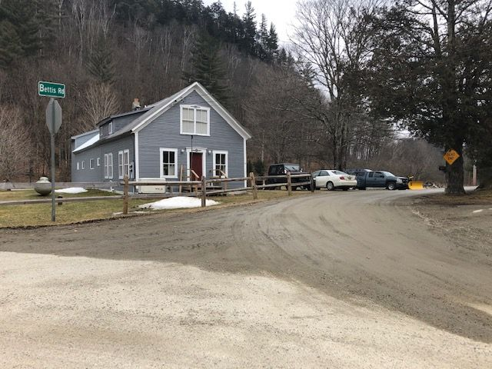

Bettis Rd. – Apron and approach
The apron shall taper to road width and extend to the speed limit sign. The apron and approach will extend 355 feet from Churchville Rd.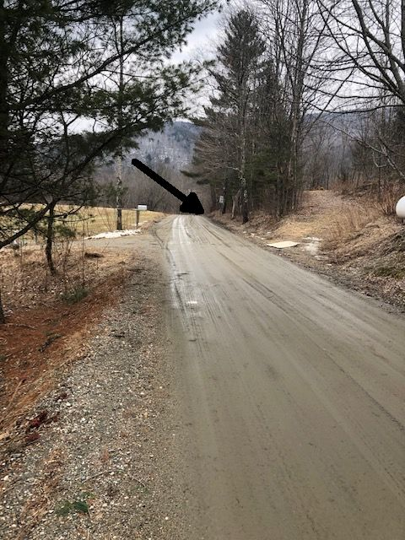

- Paved Apron – at junction of Blair Hill Rd. and Route 100.
Contractor shall cold plane 24 inches into Route 100 (24 inches x 46 feet) to assure proper mating of apron with highway pavement. Area to be cold planed is shown between the arrows.
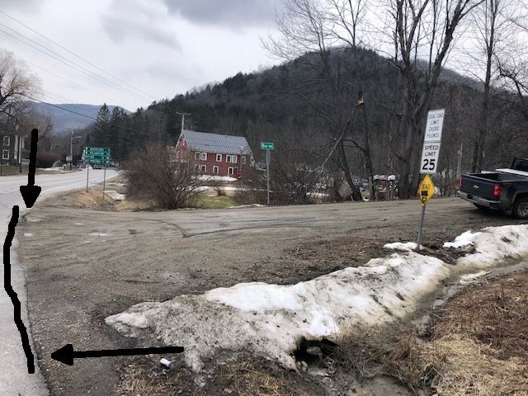

Insurance Requirements: The Town of Hancock requires that all Contractors or Persons working for the Town of Hancock carry a General liability Policy of no less than One million Dollars ($1,000,000.00) with the Town of Hancock being an additional Insured. Any Contractor or Persons working for the Town of Hancock having Employees must provide the Town of Hancock with a Certificate of Worker’s Compensation meeting all State of Vermont and Federal Statues. All Insurance Certificates must be on file with the Hancock Town Clerk before work is to begin.

Additional Requirements: The Town of Hancock requires that any Vehicle exceeding the twenty-four thousand pound weight limit (24,000) with or without load, obtain an overweight permit. The Town of Hancock has restrictions on its roads and obtaining this permit is the only way to operate legally on the Hancock Road System.

Additional Requirement: The Town of Hancock requires that all construction sites be properly warned with the correct signage and cones.

Additional Requirement: The Town of Hancock requires that the Contractor provide Traffic control as needed.

Contractor Responsibilities: Furnish all Equipment, Materials, Insurances, Labor and Knowledge necessary to complete the project described herein within the timeframe allowed.

Town of Hancock’s Responsibilities: Direction so the herein described project can be completed in the timeframe allowed.

Assignment and Subcontracting: This Contract is binding upon and inures to the benefit of the heirs, successors, and assigns of the parties hereto. Neither party hereto may assign its rights or obligations under the Contract without the prior written consent of the other party. This Contract shall be governed by the laws of the State of Vermont.

Contractor shall not enter into any subcontract for performance of any services contemplated under this Contract nor assign any interest in the Contract without the prior written approval of Municipality and subject to such conditions and provisions as Municipality may deem necessary or desirable in its sole discretion. Any work performed by a subcontractor shall be fully warrantied by the Contractor. If Municipality permits the use of subcontractors, no subcontractor may perform any work under this Contract without first providing Municipality certificates of insurance showing all of the coverages required in this Contract. Contractor shall be responsible for the performance of all subcontractors. Before paying a claim that involves the use of materials or labor supplied by someone other than the Contractor, Municipality may require Contractor to supply proof of payment for such materials or labor. Contractor shall pay the subcontractor(s) for undisputed services provided by them within 30 days of receiving payment from Municipality.

Resolution of Disputes: The Town of Hancock and the winning Contractor agree to hire an independent Arbitrator to settle any and all disputes that may arise. Both parties will share the expense of an Arbitrator equally.

Warranty of work performed: Contractor will guarantee work performed to the full satisfaction of the Hancock Select Board for a minimum period of not less than one full year (12months) from the date of the final inspection. This guarantee shall cover all workmanship and any materials the Contractor supplied. In the event of a failure in any of the workmanship or materials, the Contractor will, at their expense, replace or redo any part that has failed and any other damages that may have occurred because of that failure.

More

BID AND SIGNATURE SHEET FOR HANCOCK ROAD PROJECTS

__________________________________ SUBMITTS THE FOLLOWING BID BASED ON THE
PROSPECTUS PROVIDED BY THE TOWN OF HANCOCK. IT IS FUTHER UNDERSTOOD THAT BY SUBMITTING THIS BID I/WE AGREE TO ALL THE TERMS DESCRIBED HEREIN. IT IS FURTHERMORE UNDERSTOOD THAT CONSTRUCTION PROJECTS HAVE MANY VARIABLES AND EXTRAS AND CHANGES MAY BE MADE AS THE PROJECT PROCEEDS. WE AGREE TO WORK WITH THE TOWN OF HANCOCK ON ALL CHANGES. WE FURTHER AGREE THAT ALL CHANGES WILL BE AGREED TO IN WRITING BEFORE ANY WORK IS TO PROCEED.

BID SUBMITTED:___________________________ DATE:________________________
For Paving 2023

___________________________________________________________________________
NAME AND PHONE NUMBER OF BIDDING COMANY

SIGNATURES OF COMPANYS AUTHORIZED AGENT: _________________________________

THE TOWN OF HANCOCK HEREBY ACCEPTS THE BID SUBMITTED BY:

__________________________________ ON _________________ THE HANCOCK SELECT
BOARD AGREES TO THE TERMS STATED WITHIN THIS PROSPECTUS AND FURTHER AGREES

THAT THE ABOVE NAMED COMPANY MAY BEGIN WORK AS STATED WITHIN.

HANCOCK SELECT BOARD: _____________________________________

_____________________________________

_____________________________________

END

